Semester 1 Printable Study Guide!

1. You open a can of Coke but forget to drink it (silly you!). As the Coke sits there, its temperature warms quickly at first and then slowly reaches room temperature. Draw a reasonable graph of this situation; be sure to label your axis.
2. You purchase a home for $150,110. The following equation gives the balance, b, remaining on your loan after n months. USE A GRAPHING CALCULATOR TO COMPLETE THE FOLLOWING
   1. Make a table of your balances at the end of each 12 months for the first 6 years
   2. Graph the equation and sketch a picture of your graph below.
   3. How many months will it take you to pay off the entire Home loan? (round up to the next month)
   4. Give the domain and range of this function.

For 4 through 8 Graph and give the domain and range of each function.

1. **



1. **
2. **
3. Use the table to answer the following

|  |  |  |
| --- | --- | --- |
| x | f(x) | g(x) |
| 1 | 5 | 6 |
| 2 | 6 | 5 |
| 3 | 3 | 4 |
| 4 | 4 | 3 |
| 5 | 1 | 2 |
| 6 | 2 | 1 |

* 1. f(6) =
  2. g(4) =
  3. f(g(2)) =
  4. g(f(3)) =
  5. g(f(g(1))) =
  6. f(f(f(4))) =

1. If f(x) = x + 3 and g(x) = 2x2
2. f(g(4)) =
3. g(f(3)) =
4. f(g(x)) =
5. Draw the inverse of the square root function below. Is the inverse a function?
6. Find the inverse of the following functions.
7. **
8. **
9. **
10. **
11. Show algebraically that **is an even function.
12. Show algebraically that **is an odd function.
13. Are the functions graphed below even, odd, or neither?

a) b) c)

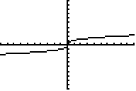 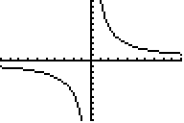 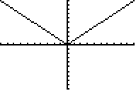

15. The figure shows an angle in standard position, with terminal side containing the point (-7, 4).

a) Mark the reference angle.

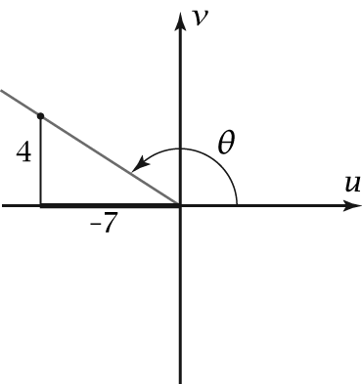

b) (Multiple Choice) What are the 6 trigonometric funtions for theat

16. • Sketch an angle of 300 o in standard position.

• Mark the reference angle and find its measure.

• (Multiple Choice)What are the six trigonometric functions of 300 o.

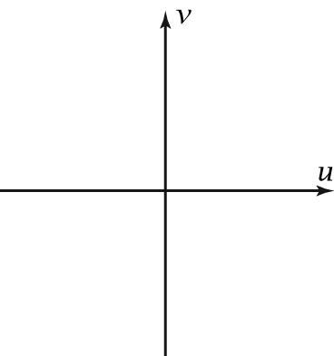

17. Explain why sec 270 o is undefined. (Show me how to calculate it)

18. Find the exact value of sin 225 o. (Draw it, it is a special triangle)

19. Find sec 77 o.

20. Find cot 158 o.

21. Find csc (-190o).

22. Find cos-1 0.3.

23. For thea = 2812 degrees,

• Find a coterminal angle between 0 and 360.

• Sketch the angle in standard position.

• Mark the reference angle and find its measure.

24. Calculate the measure of side x.

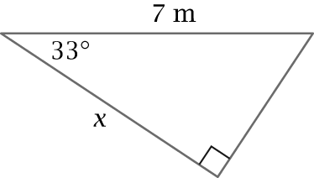

25. Calculate the measure of side *y*.

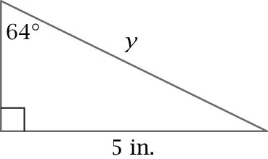

26. Calculate the measure of angle *A*.

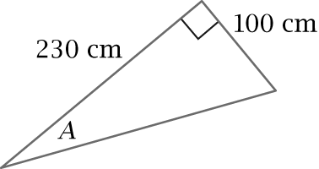

27. *Cable Car Problem:* One of the steeper streets in the United States is the 800 block of Powell Street in San Francisco, where cable cars run. Calvin measured on a brick wall 33 cm across and 5 cm down, as shown in the figure. Calculate the angle Powell Street makes with the horizontal.

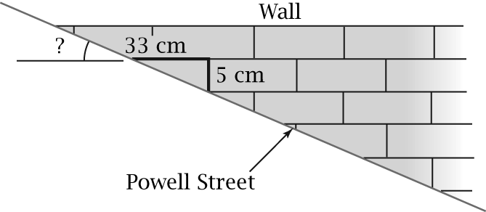

*Building Height Problem (28–29):* From a point in the parking lot, the angle of elevation to the top of an auditorium is 320. From a point 30 ft closer to the auditorium, the angle of elevation is 47o.

28. Draw a picture of the problem.

29. Calculate the height of the auditorium from the given information.

30. Find the exact radian measure of 30°.

31. Find the degree measure of  radians.

32. Sketch the graph of the parent trigonometric   
function *y* = sin *θ*. Show scales on both axes.

33. Sketch the graph of the parent circular function   
*y* = cos *x*. Show scales on both axes.

34. Find the degree measure of 3.5 radians.

35. Plot the graph of *y* = sec *x* using the window shown in this figure. Sketch the graph here, showing the vertical asymptotes.

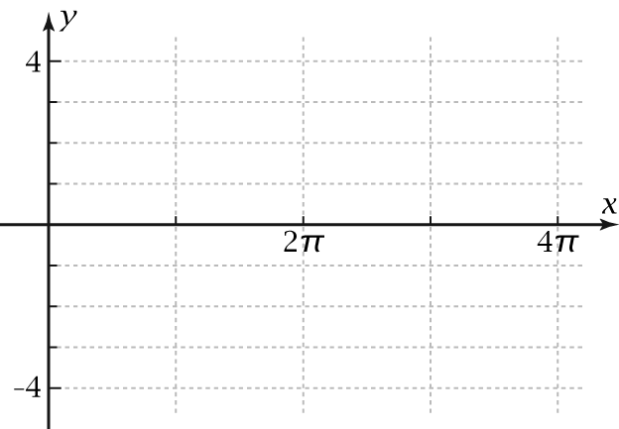

36. Plot the graph of *y* = cot *x* on your grapher using the same window as in Problem 14. Sketch the graph here.

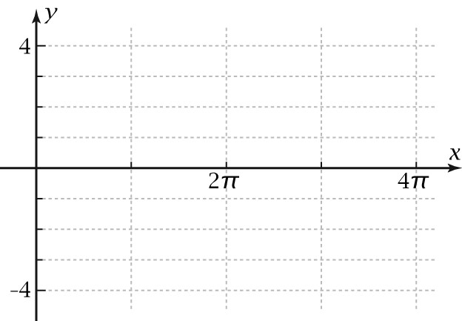

37. For this sinusoid, write the particular equation using cosine.

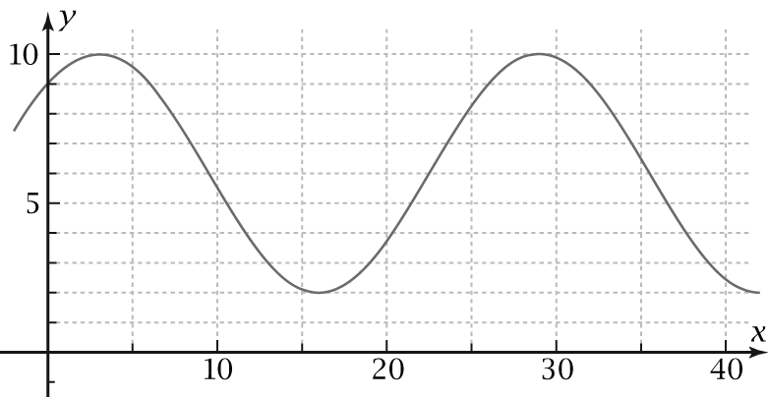

38.Write the particular equation of the sinusoid (it is a half cycle)

1. Graph the following:
   1. 
   2. 
   3. 
   4. 
2. Prove 
3. Simplify 
4. Prove 
5. Prove 
6. Prove 
7. Multiple Choice - In Parametric Equations:

a) X and Y both depend on t

b) X depends on Y which depends on t

c) Y depends on X which depends on t

d) Y and t both depend on

1. Sketch the following parametric graphs (use zoom standard for all)
   1. 
   2. 
   3. 
   4. 
   5. 
   6. 
   7. Factor 
   8. Factor 

ACT type Questions

Find Exact Answer







