Law of Sines: $\frac{sin⁡(A)}{a}=\frac{sin⁡(B)}{b}=\frac{sin⁡(C)}{c}$
The Law of Sines is important because it can help us solve problems involving right and non-right triangles.

The height breaks triangle ABC into two right triangles. Using SohCahToa, find the following:
Sin(A)= Sin(C)=
Next, solve the equations for h.
h= h=
Since both of the previous equations are equal to h, we can set them equal to each other.

Finally, divide both sides by a and c. What do you get?
B
c
a
h
b
A
C

When to use the Law of Sines:
Solving an SAA triangle, solving a ASA triangle, and the ambiguous case (SSA)
____________ ____________ ___________

7
60°░
5
6
55°░
50°░
35°░
35°░
8

Example #2. SAA
Example #1. SAA
<C=30°
<C=82°
a
b
a
b
<B=_____
<A=64°
c=14
<A=46°
<B=_____
c=56 inc
Step #1: Find the measure of the missing angle

Step #2 Use Law of Sines to find missing sides

<C=22.5°
Example #4: ASA
<C=33.5°
Example #3: ASA
b=12
b=76
a
a
<B=_____
c
<A=40°
c
<A=50°
<B=_____

Law of Cosines: $c^{2}=a^{2}+b^{2}-2ab*cos(C)$
The Law of Cosines is used to solve SSS and SAS triangles.
SAS
SSS

Example #1: SAS
Step 1: Use the Law of Cosines to find the side opposite the given angle

C
Step 2: Use the Law of Sines to find the angle opposite the shortest side
a
b=20

B
c=30
<A=60°
Step 3: Find the measure of the third angle

C
Example #2: SSS
b=9
a=6

B
c=4
A

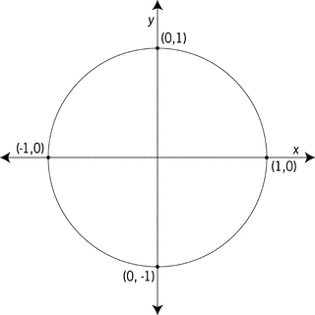
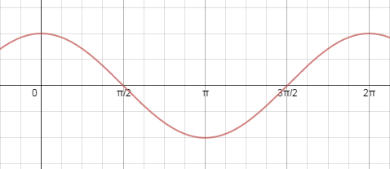

A
B
C
a
c
b
Let's say that <C=90°. What is cos(C)?

Thus, if C=90° the Law of Cosines becomes the ________________ ___________

If <C is less than 90°, is cos(c) positive or negative?

Thus, if <C is less than 90°, is the length of c greater than or less the length if <C=90°?

A
B
C
a
c
b

A
B
C
a
c
b
If <C is greater than 90°, is cos(c) positive or negative?

Thus, if <C is greater than 90°, is the length of c greater than or less the length if <C=90°?

