0.2 Converting Units

0.3 Density

1) Find the density if volume is 3.00 mL and mass is 2.50 g.

1. Find the volume if density is 5.65 g/mL and mass is 500.0 kg. (Careful of different units!)
2. Find the mass of a 20 cm x 20cm x 50cm bar of gold (19.3 g/cm3 is the density of gold).

0.4 Significant Figures

Count the sig figs.

0.00500

1.2345

1.53520

2.33000

5,000,000

5,000.000

Do some calculations using the right number of sig figs:

5.00 cm x 5.000 cm

3.333 mol x 2.00 g/mol

1.000 m x 523.152 m

0.5 Scientific Notation

Covert to Scientific Notation

5,100,000

3,000

0.000 015 23 (the spaces are just to help you count)

0.000 000 0324

Convert to Standard Notation

1.5 x 105

7.77 x 10-4

Do some math

(3.0 x 105) + (2.0 x 103)

(3.0 x 105) x (2.0 x 103)

1.2 States of Matter

Answer the following three questions for Gas, Liquid, and Solid

Is the volume fixed?

Is the mass fixed?

Is the shape fixed?

What is condensation?

What is sublimation?

What is deposition?

1.3 Mixtures & Pure Substance

What’s the difference between a homogeneous mixture, heterogeneous mixture, element, or compound?

For each say whether it’s a homogeneous mixture, heterogeneous mixture, element, or compound:

Silver Pizza Sugar Chromium

Water Hydrogen Beer Salt

Oxygen Gold Magnesium Dime

Air Sulfur Carbon Nickel

2.1 Subatomic Particles

For each, list the atomic #, atomic mass, # of protons, electrons, & neutrons.

You can use a periodic table.

Boron-12

Oxygen-16

Carbon-13

Magnesium-26

Lithium with 5 neutrons

Tungsten with 111 neutrons

Describe Thompson’s cathode-ray tube experiment and Rutherford’s gold foil experiment and what was discovered from each.

2.3 Grams, Moles, Molecules

0.2 Converting Units

Convert 5.025 moles of Helium to grams.

Convert 5,360 grams of Gold to moles.

Convert 2.05 x 1024 atoms of Boron to moles.

Convert 10.00 moles of Silver to atoms.

Convert 15.00 grams of water to molecules.

Convert 1.2044 x 1024 molecules of CO2 to grams.

3.1 Parts of the Periodic Table

Use the periodic table below (try not to use your book here!)

Which group are the:

Alkali metals

Halogens

Noble Gases

Transition Metals

Give 2 properties of the Alkali-Earth Metals

Give 2 properties of the transition metals

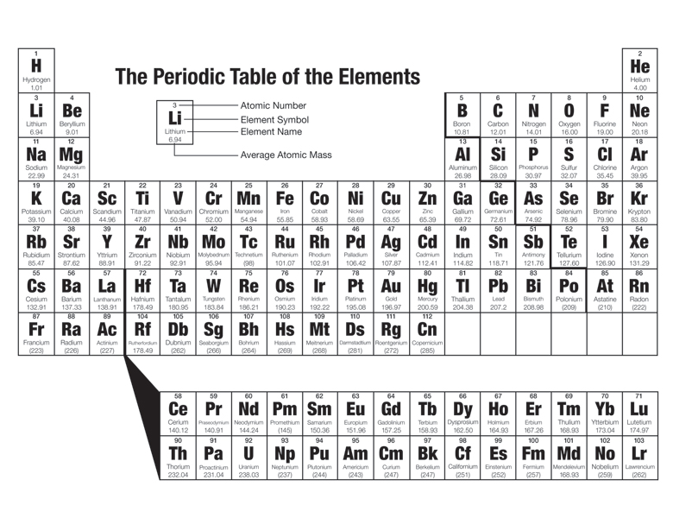

3.2 Periodic Trends

Here are the trends:

Atomic Radius

Melting, Boiling Point

Electronegativity

Ionization energy

Define each and *explain why each increases or decreases* as you go across *and* down the table.

4.1 ID Ionic & Covalent Compounds

Identify the following compounds as Ionic, polar-covalent, or non-polar covalent. You may use pg 194 & 195 in your textbook & your polyatomic ions sheet.

F2

H2O

NaCl

NH4Cl

Explain why we subtract the electronegativity to find the nature of the bond.

4.2 Names & Formulas of Ionic & Covalent Compounds

4.1 ID Ionic & Covalent Compounds

Name each of these compounds (First you might need to find out whether they are Ionic or Covalent!)

You may use pg 194, 195 of your textbook as well as your polyatomic ions sheet.

NaCl

PO3

C3S4

LiF

Cs2CO3

CoBr2

Cu2S3

4.3 Lewis Structures

Sketch the Lewis Diagrams for each of these molecules:

PBr3

N2H2

CH3OH

NO2-1

C2H2