4.3 Lewis Structures (S) Notes

What’s a Valence Electron?

Shortcut to find # of valence electrons

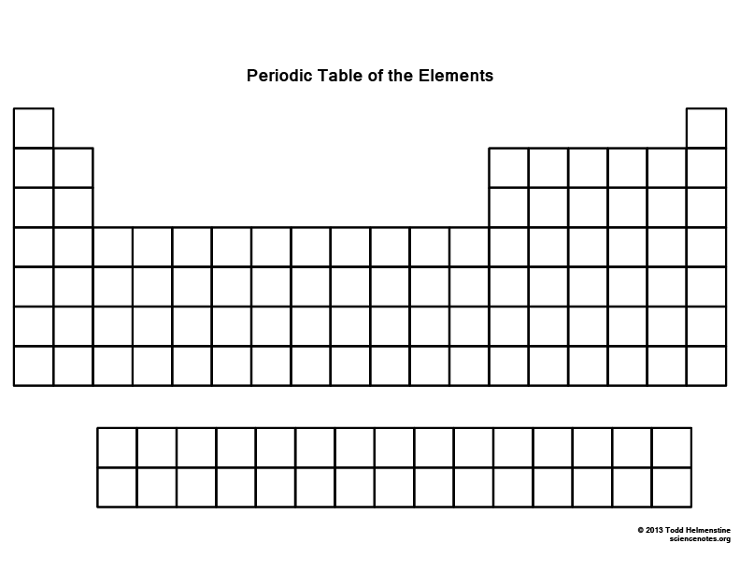

Examples

Review Valence Electrons

H Be

O F

F Ne

Simple Molecules

H2O

Hund’s Rule

Octet Rule

HF

NH3

Notation

Dot

Dash

Double Dash

Complex Molecules

C2H6

How to Check your Answer

Count around each atom

Count *all* the electrons

CH2Cl2

CH3OHPolyatomic Ions

Symbols/Steps with Polyatomic Ions

NO3-

CN-

Tips

At the center: C

At the center: Lowest Electronegativity

Not at the center:

Look for DB or TB

If it doesn’t work, start back from scratch, but don’t erase what you’ve done!

O22-

PO43-

Double & Triple Bonds

O2

C2H2

N2