Periodic Trends Discovery Activity

Background (Yes, read this! Even though you usually skip it. You know who you are.)
The periodic table organizes the elements in a very special way. Because of how they elements are groups, certain patterns or trends show up in the periodic table. Trends are things that happen as you move across or down the table. For example, the elements usually* get heavier as you go to the right. This would be considered a trend because, for example, Lithium is not as heavy as Beryllium, which is not as heavy as Boron, which is not as heavy as Carbon, etc. We say “atomic mass increases as you go across to the right” for the trend.
Also, going down, there are typically more protons the further down you go. This is a trend because Nitrogen has fewer protons than Phosphorous, which has fewer protons than Arsenic, etc. We say “the number of protons increases as you go down a group”. Notice how I chose any column and worked my way down, but I did not jump left and right. Trends are things that are typically true no matter what column or row you select and go down or across.
Today you’re going to figure out some trends. Some of these might be difficult because we’ll be using strange vocabulary that you haven’t seen before, but if you think about it and talk with your group, I think you can figure it out. First, I’ll give you some things you’ll need to know (TYNTK). Then, I’ll give you a trend to figure out and you’ll write a sentence to say whether it is increasing or decreasing. You’ll need to defend your sentence with one of the TYNTK.

*Trends aren’t absolute. Here, I say usually because of elements like Cobalt and Nickel. Check out their Atomic Mass. Weird, right?

TYNTK: Things You Need To Know
(some of these you already do know!)
- The number of protons is the atomic number (usually above the element symbol).
- As you go up in energy levels, you get much bigger electron orbital clouds.
- All atoms want a full outer electron shell (this is almost always 8 valence electrons).
- Sometimes a full set of valence electrons is achieved by adding electrons and other times it’s achieved by subtracting electrons. Think about which is easiest.
- More protons means a stronger pull on the electrons. A stronger pull on electrons means the electrons are closer (the electron orbital actually shrinks a little!).
- Elements with too many electrons don’t bond well to themselves because all the atoms want just a few electrons and nobody wants to give up any. Elements with too few electrons don’t bond well to themselves because all the atoms want to give up just a few electrons and nobody wants to take them. Elements with 4 electrons bond best to themselves because they’re willing to give up or accept 4 electrons to make 8.
- Electrons are pulled by the nucleus, however, they’re repelled (pushed away) by other electrons. This means the outermost electrons aren’t pulled as strongly by the nucleus. We call this effect electron shielding.
- The d-block (usually) only has 2 valence electrons, but the d-orbital is more willing to accept or give up electrons than most other orbitals.

Trends
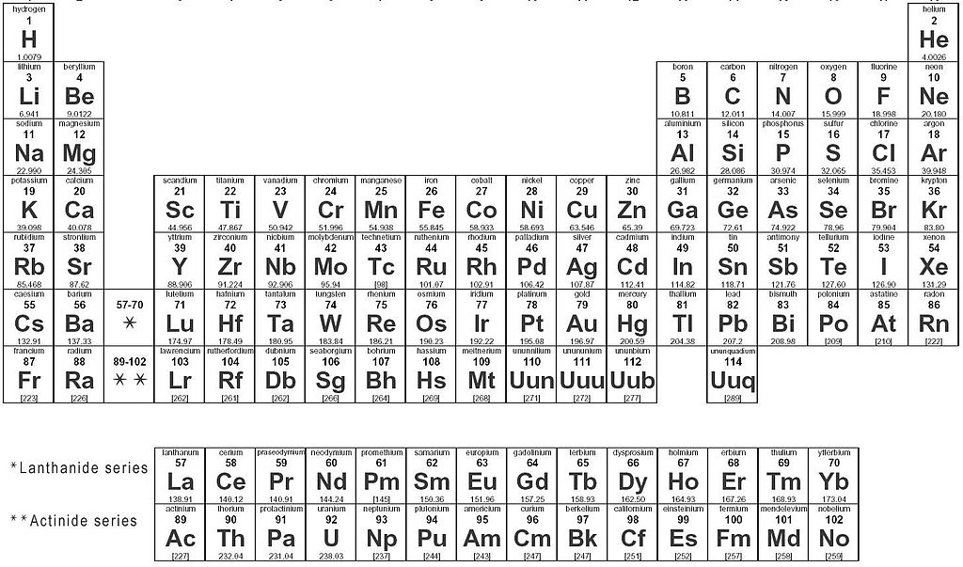
Trends Going Across, to the Right

Trends
Going
Down

Trend Name | Going Across, to the Right | Going Down
Atomic Mass  -this is basically the protons + neutrons.  -this is also basically the mass of the nucleus. | As you go to the right, Atomic Mass increases. | As you go down, Atomic Mass increases.
 | 1. The number of protons is the atomic number, and that number increases, as do the # of neutrons, as you go to the right. | 1. The number of protons is the atomic number, and that number increases, as do the # of neutrons, as you go down.
Atomic Radius
-the size (radius) of the electron orbital clouds.
-in other words, the size of the atom.
Electronegativity
-How strongly an atom pulls on electrons (when in a bond).
Ionization Energy
-how much energy it takes to remove an electron from an atom.
Melting & Boiling Point
-temperature at which solid become liquid or liquid become gas
-based on strength of element bonding w/ itself

