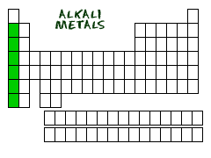
Alkali Metals are in group 1, but they do not include Hydrogen!!
(So make sure people do not include Hydrogen when marking their Periodic table!
Properties: (1) They are very, very reactive (they explode when they touch water!)
- They are a metal (duh).

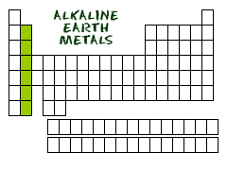
Alkaline-Earth Metals are in group 2.
Properties: (1) They are very reactive.
- They are a metal (duh).

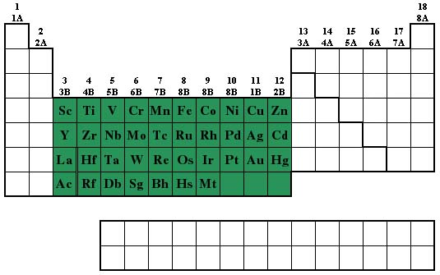

The Transition Metals include groups 3 through 12!
Properties: (1) They bond really well to themselves compared to most other elements.
- They are a metal (duh).

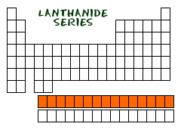
The Lanthanides are on the bottom of the periodic table, so we do not give them a group number.
Property: (1) They are shiny metals and similar to alkaline-earth metals.
(2) They are also known as rare-earth metals because, well, they are very rare on Earth!
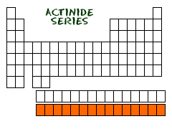

The Actinides are on the bottom of the periodic table, so we do not give them a group number.
Properties: (1) They are radioactive because they are unstable and their nucleus will break apart because they are too big.
- Most of these are synthetic, meaning they were made in a lab and are not found naturally on Earth.

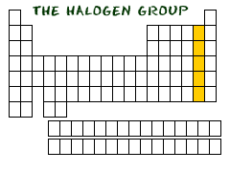
The Halogens are in group 17.
Properties: (1) They are the most reactive non-metal.
(2) They like to react with Alkali Metals (because they “complete” them!)

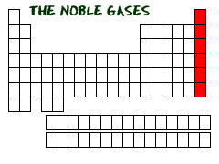

The Noble Gases are group 18.
Properties: (1) They are unreactive because they are “happy” (they have full valence electron orbitals)
(2) They were discovered last of the groups (because of how unreactive they are)

