3.1 Parts of the Periodic Table Activity

- Everyone has a “cheat-sheet”.
- You’re not allowed to show others your cheat-sheet, you must read off it.
- Goal: fill up your notes sheet with all the necessary information by going around the room and asking others for information about their “group”
- Some of the information you’ll have to figure out yourself--not all of it is on the “cheat-sheet”!
- You should use this as a study guide!!

Part 1: Location
Label the parts of the periodic table below.
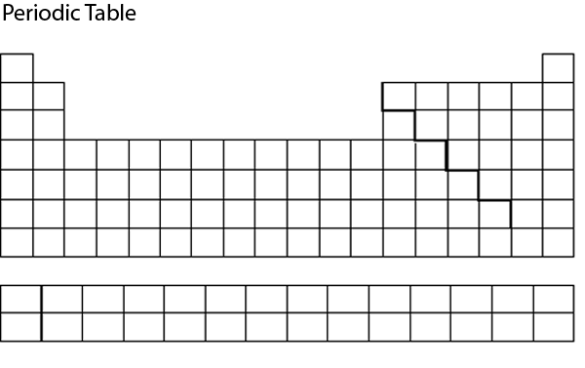

Part 2: Properties

Alkali Metals

Group _______ Number of Valence Electrons ____ In the ____ Block

Properties (1) _________________________ (2) _________________________

Examples (1) ____________________ (2) ____________________

Alkaline-Earth Metals-----------------------------------------------

Group _______ Number of Valence Electrons ____ In the ____ Block

Properties (1) _________________________ (2) _________________________

Examples (1) ____________________ (2) ____________________

Transition Metals

Group _______ Number of Valence Electrons ____ In the ____ Block

Properties (1) _________________________ (2) _________________________

Examples (1) ____________________ (2) ____________________

Lanthanides-------------------------------------------------------

Group _______ Number of Valence Electrons ____ In the ____ Block

Properties (1) _________________________ (2) _________________________

Examples (1) ____________________ (2) ____________________

Actinides---------------------------------------------------------

Group _______ Number of Valence Electrons ____ In the ____ Block

Properties (1) _________________________ (2) _________________________

Examples (1) ____________________ (2) ____________________

Halogens---------------------------------------------------------

Group _______ Number of Valence Electrons ____ In the ____ Block

Properties (1) _________________________ (2) _________________________

Examples (1) ____________________ (2) ____________________

Noble Gases------------------------------------------------------

Group _______ Number of Valence Electrons ____ In the ____ Block

Properties (1) _________________________ (2) _________________________

Examples (1) ____________________ (2) ____________________

