Orbital Cloud Web-quest
So it turns out that electrons actually don’t travel around in orbits like we thought! Instead, they move around in crazy patterns, but seem to stay in a certain area. We’ll call this area an orbital cloud.
If you remember, because of the Heisenberg Uncertainty Principal, we can either know where an electron is, or how fast it’s moving, but not both (weird, right?). So we have these orbital clouds that tell us approximately where the electron is most likely to be.
During this club cranium web-quest, you’ll be working to figure out (a) what these orbital clouds look like, (b) why they look like they do, and (c) how we can describe where an electron is.

Part 1: The basic orbital shapes.
There are 4 basic orbital shapes, each called a letter: s, p, d, and f. Look at Mr. Newman’s website (mrnewmanswebsite.weebly.com) and sketch the s, p, and d orbitals below, label them, and then answer the questions.

Questions
Which orbital cloud above do you think electrons would go to first?

Why?

Why would electrons do what you just explained right above?

STOP! You need to check with Mr. Newman before continuing; otherwise the next section will not make sense!

Part 2: Energy Levels
You may continue by clicking on the “simplest” orbital from above. (There are buttons at the bottom of the page or drop-down menus from the links above.)

When you follow the link, you’ll see a few different Energy Levels of these orbital clouds. Sketch them below.

Electrons always want to fall into the lowest energy level. Which picture depicts the lowest energy level? (You can label it above.)

Two (2) electrons can fit into each energy level. Above, you can see energy levels 1, 2, and 3. How many electrons can fit into the first two (2) energy levels of this orbital?

How many electrons can fit into the first five (5) energy levels of this orbital?

Refer back to the previous page: which orbital (after this one) is the next most likely for electrons to go to (between s, p, and d)?

Why?

STOP! You need to check with Mr. Newman before continuing; otherwise the next section will not make sense!

Part 3: Orientations of Orbitals
Continue by clicking on the “next most basic shape” from your answer to the last question above.

You’ll notice that there are three different orientations of this shape, even though they’re all at the same energy level. Sketch all three orientations.

The x-axis goes left to right, the z-axis goes up and down, and the y-axis goes forward and backward (into and out of the page). Based on this, we call the three orientations P_{x}, P_{y}, and P_{z}. Which do you think is which? You can label them above.

Two electrons can fit in each orientation. How many total electrons can fit in the above Energy Level of this shape?

Below, on the left, sketch what you think it would look like if you put all three of the orbitals orientations together.

Above, on the right, look at the “P orbitals part 2” page, and sketch what all three combined orbital orientations actually look like.

Why does it make sense that these orbital orientations look like that?

Part 4: Orientations and Energy Levels
One strange thing about the p orbitals is that they don’t start at energy level 1. The orientations you worked with on the last page are actually at energy level 2! Lower on this page, you’ll see energy level 2 and energy level 3 together. Again, there are 3 orientations for the p shape at energy level 2. Sketch those three below.

How many total electrons can fit in the three p orbitals at the second and third energy levels (total pictured above)?

STOP! You need to check with Mr. Newman before continuing; otherwise the next section will not make sense!

Part 5: The Crazier Orientations
Continue on to the d orientations and sketch all 5 orientations below.

Again, only 2 electrons fit in every orientation. How many total electrons fit in all the orbital orientations you just sketched?

Look at the combined orientation from all the orbitals you sketched (I won’t make you sketch it). Why does this overall shape make sense?

Write the number of electrons allowed at a given energy level for each of the shapes below.

s ________ p ________ d ________

If this pattern continues, how many do you think would fit in the f orbital?

STOP! You need to check with Mr. Newman before continuing; otherwise the next section will not make sense!

I want you to look at the periodic table of elements. There are 4 numbers above that you wrote down. Do you see these numbers in the shape of the periodic table?

Where do you see the numbers? Explain by sketching a picture below and pointing them out.

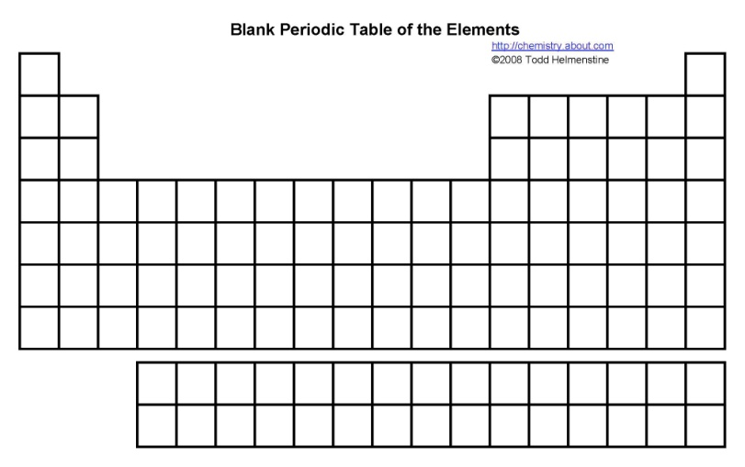

Part 6: The Address
We need a way to tell where an electron is, kind of like an address for an electron. In the space below, I want you to come up with a system to describe where an electron is and be ready to present this system to the class.

