Name: ________________________

Moles of Chalk Lab
Objective
The goal of this lab is to figure out how many moles of sidewalk chalk it takes to write your name.

Hypothesis
Make an educated guess as to the number of moles it takes to write your name. If you aren’t sure how much a mole of calcium carbonate is, make an educated guess as to the number of grams it takes and then convert your grams to moles in the hypothesis.

Procedure
Weigh a piece of sidewalk chalk and write your name outside on the sidewalk. Weigh the chalk again, and determine the number of moles of calcium carbonate that were used.

Analysis
In your analysis paragraph, you should explain how you arrived at the solution to the question “How many moles of chalk does it take to write your name?” Reference your hypothesis and come up with a % error using the following formula:

The % error should be given as a percent.

Error Analysis
Finally, you should explain any sources for actual error in your experiment. Remember that it is very rare for an experiment to have fewer than three sources of error.

Other Analysis Questions
For these, you may have to measure some things using a scale or ruler.
- Suppose that paperclips are made of aluminum (they’re usually steel, an alloy). How many moles of aluminum is a single paper clip?
- Make an educated guess as to how much pencil lead (graphite) it takes to write your name on a sheet of paper. You should be creative in your approach and demonstrate that you know how to convert grams to moles! Oh, and graphite is made of carbon.
- The smallest logo ever printed was “IBM” by putting 35 xenon atoms on a copper substrate background. (See picture below.)
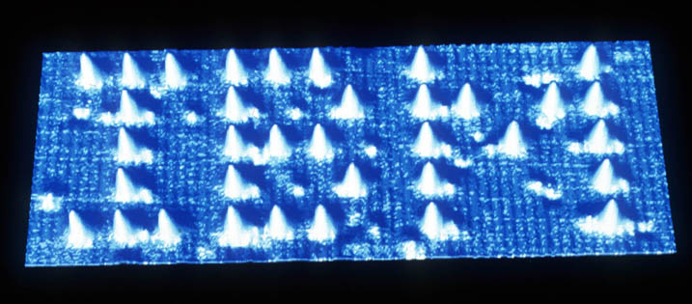
How many moles is this logo?
- One of the world’s largest logos was allegedly made of 70,000 empty coke bottles to celebrate the 100th anniversary of the Coca-cola company. Suppose that the logo was made of aluminum coke cans instead: how many moles of aluminum would that be? An empty coke can weights about 14 grams.

