0.4 Significant Figures Notes
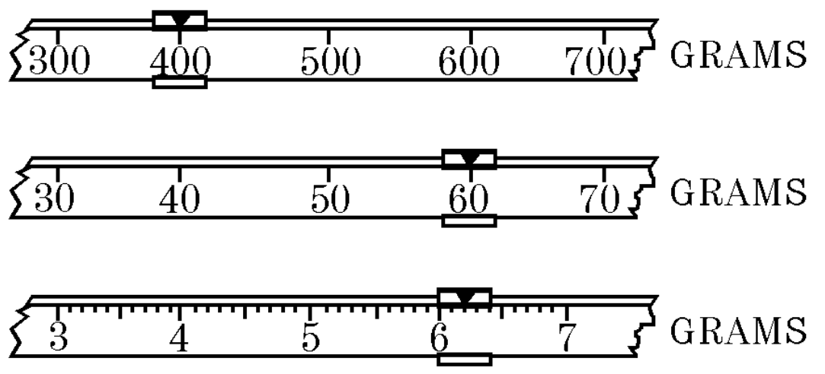
The triple-beam balance to the right gives a mass of what?

How accurately can we measure anything?

“You can measure ________________________________________________”

So you have 11 identical rocks on the beam above. What is the mass of each rock?

42.3818181818181818181818181818181818181818... grams?

Answer: _______________________________
(to be answered at the end of the lesson)
This is why we need “sig figs”.

Counting Sig Figs

Just two situations (compared to your book’s 5 “rules” on page ____________)

Situation 1: | Situation 2:
Start from _____________________  End at ________________________ | Start from _____________________  End at ________________________
Examples: | Examples:
Tricky Examples: | Tricky Examples:

Calculating Sig Figs

“Can only be as sure as _____________________________________”

Multiplying or Dividing:

We care about ____________________________________.
Examples:

Find density if 25.42 g = mass, 32.4 = mL.

Adding or Subtracting:

We care about ____________________________________.
Examples:

Mr. Newman measured his child and saw that he grew from 50.4 cm to 55.234 cm in the first week of his life. How much did he grow?

(More practice can be found on page _________________)

Special Cases for Sig Figs

When talking about exact values, treat them like they have _________________ sig figs.

Example: 5 apples in a basket.
Misguided students: “Are we sure there are exactly 5?” “Maybe there are 5.0001 apples?”

Example 2: convert mm to m.

(Hey, you can do the problem on the other side of the notes now!)

