0.3 Density Notes
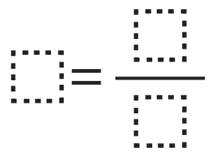Equation for density

Visual Example
Not Dense Avg. Density Very Dense

Density & Buoyancy
If an object is more dense than the surrounding substance, then it will __________.
Examples (in liquid or gas):

Specific buoyancy of elements and compounds can be found on page ___________.

Calculating Density, Mass, or Volume
Example Problems: (more of these are on page ________________)

